SMART ENERGY MANAGEMENT SYSTEM

A Research Report
Submitted in partial fulfillment of the Requirements for the award of the Degree of
MASTER OF SCIENCE (INFORMATION TECHNOLOGY)

By
Ahmed Dilshad Shaikh Seat Number: MIT251009
Under the esteemed guidance of
Asst. Prof. Priya Maurya


DEPARTMENT OF INFORMATION TECHNOLOGY
SHRI RAJASTHANI SEVA SANGH’S SMT.PARMESHWARIDEVI DURGADUTT TIBERWALA LIONS JUHU COLLEGE OF ARTS, COMMERCE & SCIENCE
(Affiliated to University of Mumbai) (Autonomous)

JB NAGAR, ANDHERI EAST, MUMBAI MAHARASHTRA - 400059 2025 - 26

TABLE OF CONTENTS

Sr. No. | Contents | Page No.
1 | INTRODUCTION | 1
2 | IMPORTANCE OF SMART ENERGY SYSTEMS | 2
3 | ROLE OF BIG DATA ANALYTICS | 3
4 | WORKING / ARCHITECTURE | 4
5 | TECHNOLOGIES USED | 5
6 | APPLICATIONS | 6
7 | ADVANTAGES | 7
8 | CHALLENGES | 8
9 | FUTURE SCOPE | 9
10 | CONCLUSION | 10

INTRODUCTION
The global energy landscape is undergoing a paradigm shift. Traditional power grids, characterized by one-way communication and centralized generation, are struggling to keep pace with the volatile nature of renewable energy and the exponential rise in electricity demand. Smart Energy Management Systems (SEMS) emerge as the digital nervous system of modern infrastructure, integrating Information and Communication Technology (ICT) with power systems.
SEMS represents an integrated framework designed to monitor, optimize, and control the generation, distribution, and consumption of energy. Unlike legacy systems, SEMS leverages Big Data Analytics to transform raw bits of information from millions of endpoints into actionable intelligence.

The Role of Data in Energy Evolution
The transition to "Smart" systems is driven by the need for decarbonization and efficiency. By utilizing data from smart meters and IoT sensors, SEMS can:
- Balance the grid in real-time.
- Integrate intermittent sources like solar and wind.
- Enable "Prosumers" (consumers who also produce energy).

Furthermore, the evolution of energy systems is closely linked with the advancement of digital technologies. The ability to collect and analyze large-scale data enables better coordination between energy generation and consumption. This shift from traditional systems to intelligent, data-driven systems ensures improved efficiency, reliability, and sustainability in modern energy infrastructure.

IMPORTANCE OF SMART ENERGY SYSTEMS
The importance of SEMS transcends simple cost-saving; it is a fundamental requirement for the Smart City of the future. The primary drivers for adopting these systems include:
- Grid Stability and Reliability: Traditional grids are prone to cascading failures. SEMS provides Self-healing capabilities by detecting anomalies and rerouting power before a blackout occurs.
- Sustainability: By analyzing weather patterns and consumption trends, SEMS optimizes the use of renewable energy, reducing the reliance on carbon-heavy "peaker" plants during high demand.
- Economic Efficiency: For utilities, it reduces operational costs through predictive maintenance. For consumers, it provides granular visibility into usage, allowing for shift-loading (using heavy appliances when rates are lower).
- Demand Response (DR): SEMS allows utilities to communicate with smart appliances to reduce load during peak hours, effectively flattening the demand curve.

Smart Energy Management Systems also play a key role in improving communication between energy providers and consumers. With the help of digital technologies, users can access real-time information about their energy usage through mobile apps or dashboards. This transparency helps consumers make informed decisions and encourages energy-saving behavior.

Moreover, these systems support the development of smart cities by enabling efficient energy distribution across residential, commercial, and industrial sectors. By combining data analytics with automation, SEMS ensures that energy resources are used in the most optimal way.

ROLE OF BIG DATA ANALYTICS
In the context of Smart Energy, "Big Data" is defined by the four Vs: Volume, Velocity, Variety, and Veracity.
- Volume: Smart meters alone generate terabytes of data daily, recording consumption at 15-minute intervals compared to the traditional once-a-month manual reading.
- Velocity: Data must be processed in near real-time to maintain grid frequency and stability.
- Variety: Analytics engines must ingest structured data (meter readings), semi-structured data (XML logs), and unstructured data (weather reports, social media sentiment during outages).
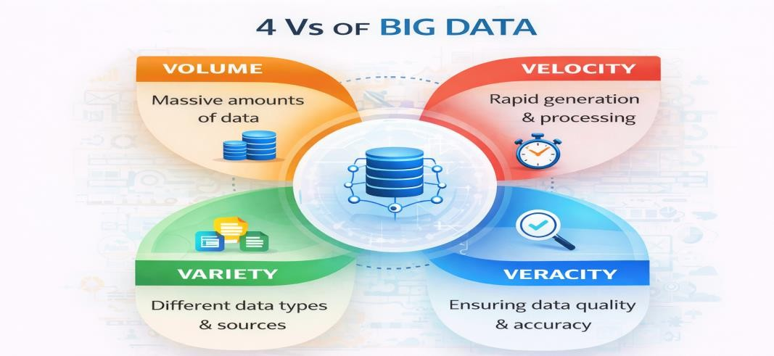

The Analytical Pipeline
Big Data Analytics serves three primary functions in SEMS:
- Descriptive: Analyzing historical data to understand past consumption trends.
- Predictive: Using Machine Learning (ML) models to forecast future load.
- Prescriptive: Suggesting the best course of action, such as when to discharge a battery storage system.

WORKING / ARCHITECTURE
The architecture of a Smart Energy Management System is typically structured into a four-layer model to ensure scalability and security:

Perception Layer (Sensing)
The physical layer consisting of Smart Meters, Phasor Measurement Units (PMUs), and IoT-enabled appliances. These devices collect physical parameters like voltage, current, and temperature.

Communication Layer (Network)
This layer acts as the bridge. It utilizes various protocols such as ZigBee, LoRaWAN, 5G, and Power Line Communication (PLC) to transmit data from the perception layer to the central servers.

Data Processing Layer (Analytics)
Where the "Big Data" magic happens. Technologies like Apache Spark or Hadoop process the massive streams of incoming data. Here, noise is filtered, and data is stored in distributed databases like MongoDB or Cassandra.

Application Layer (Control)
The interface for the end-user or grid operator. This includes dashboards for energy visualization, billing modules, and automated control systems that send commands back to the devices (e.g., turning off an HVAC system during a peak event).
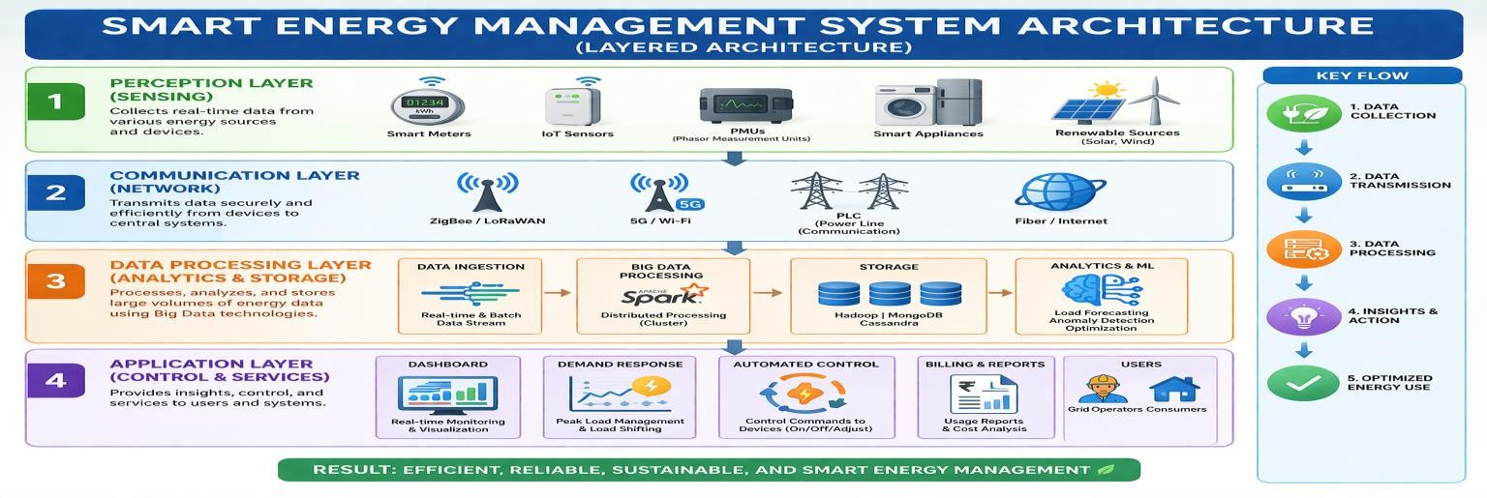

TECHNOLOGIES USED
To implement the architecture described above, a robust stack of technologies is required:
- Internet of Things (IoT): The hardware backbone for data collection.
- Edge Computing: Processing data closer to the source (at the meter level) to reduce latency and bandwidth usage.
- Cloud Computing: For long-term storage and heavy-duty analytical processing.
- Machine Learning Algorithms: Specifically, Recurrent Neural Networks (RNNs) and Long Short-Term Memory (LSTM) networks are frequently used for time-series energy forecasting.

In addition to these technologies, advanced data analytics tools and platforms are used to process and visualize energy data. Tools like Hadoop and Apache Spark help in handling large volumes of data efficiently, while data visualization tools provide insights through dashboards and reports.

Furthermore, Artificial Intelligence plays an important role in improving decision-making. AI-based models can analyze patterns in energy consumption and predict future demand accurately. This helps in better planning and efficient utilization of energy resources.

APPLICATIONS
In 2026, the application of Smart Energy Management Systems has moved beyond simple monitoring into the realm of Active Grid Participation.

Smart Homes and HEMS
Home Energy Management Systems (HEMS) now act as local orchestrators. Beyond controlling smart thermostats, modern HEMS integrate with rooftop solar and home battery storage. Through Big Data, they analyze real-time electricity pricing (Time-of-Use tariffs) to automatically run heavy loads (like dishwashers or EV chargers) when energy is cheapest.

Virtual Power Plants (VPPs)
One of the most significant 2026 applications is the VPP. By aggregating thousands of decentralized energy resources—such as residential batteries and electric vehicles—utilities can create a "cloud-based" power plant. When the grid faces a peak demand spike, the central SEMS sends a signal to these distributed units to discharge energy back into the grid, preventing the need for fossil-fuel "peaker" plants.

Data Centers as Energy Partners
Traditionally passive consumers, data centers now serve as active grid stabilizers. By leveraging their massive Uninterruptible Power Supply (UPS) batteries, they provide short-term frequency regulation to the grid. Additionally, many modern centers now employ "Waste Heat Recovery," piping excess heat from server racks into local municipal heating networks.

Vehicle-to-Grid (V2G)
The widespread adoption of bidirectional charging has turned Electric Vehicles into mobile energy storage units. SEMS now manages the V2G ecosystem, ensuring that an EV is fully charged for the morning commute while allowing it to support the grid during evening peak hours.

ADVANTAGES
The transition to data-driven energy management provides multi-layered benefits:
- Environmental Impact: By effectively managing "Green Flexibility," SEMS allows for a higher penetration of intermittent renewables (wind/solar) without compromising grid stability.
- Economic Empowerment: Consumers are no longer just "users" but "Prosumers." Through VPPs and net metering, individuals can monetize their stored energy, effectively turning their home into a revenue-generating asset.
- Operational Resilience: With Predictive Maintenance, utilities can identify a failing transformer weeks before it explodes, reducing "System Average Interruption Duration" (SAIDI) scores significantly.
- Peak Shaving: By shifting demand away from peak hours, SEMS reduces the total infrastructure capacity required, saving billions in unnecessary grid expansions.
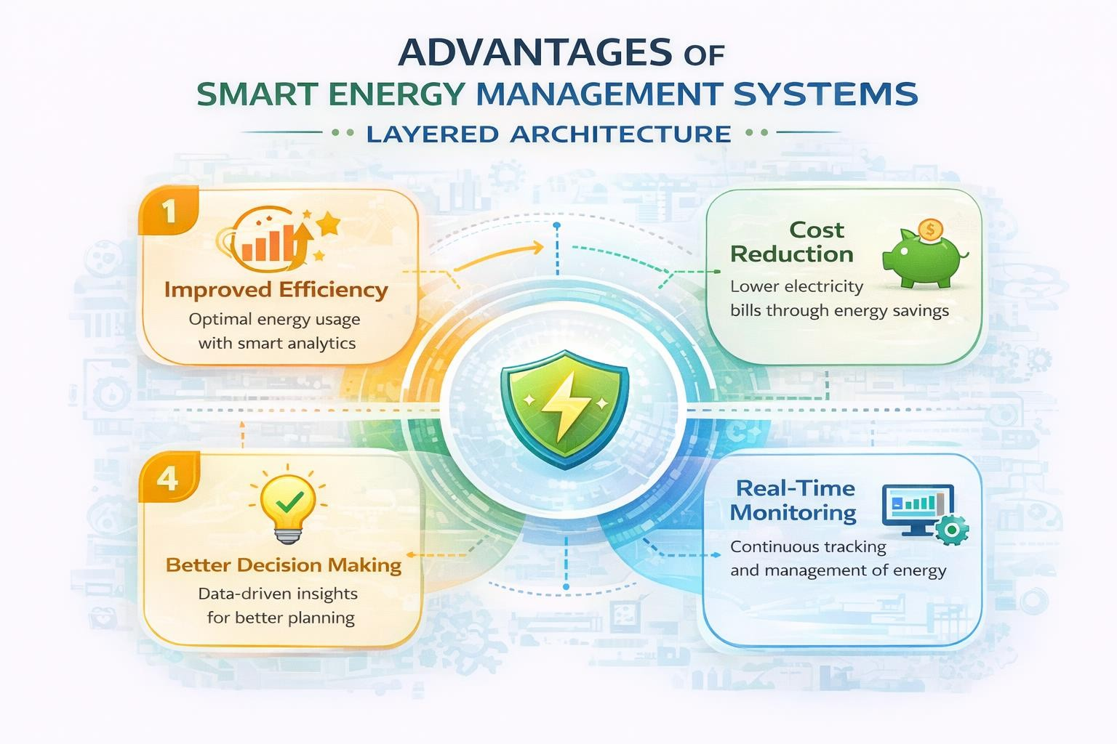

CHALLENGES
Despite the benefits, the integration of Big Data into energy systems faces several "Ironclad" hurdles:

The "Duck Curve" Intensification
As solar adoption grows, the "Duck Curve"—the gap between midday oversupply and evening peak demand—has become deeper. Managing this extreme volatility requires sophisticated AI models that must operate with 99.99% accuracy to prevent grid-wide frequency instability.

Cybersecurity and Data Sovereignty
As energy systems become more digitalized, the "Attack Surface" expands. In 2026, Ransomware remains a critical threat to SCADA (Supervisory Control and Data Acquisition) systems. Furthermore, different regions now enforce strict Data Sovereignty laws, requiring that energy consumption data stays within national borders, complicating the use of global public cloud providers.

Interoperability with Legacy Systems
Many utility providers still rely on 20-year-old analog hardware. Bridging the gap between "Relay Protection 2.0" (digital/adaptive) and electromechanical legacy devices remains a high-cost engineering challenge.

Data Privacy Issues
Smart energy systems collect user data, which can lead to privacy and security risks if not properly protected.

High Implementation Cost
Setting up smart energy systems requires high initial investment in devices, infrastructure, and technology.

FUTURE SCOPE
The horizon of SEMS is defined by the shift from Raw Capacity to Intelligence.
- Autonomous Grids: The next decade will see the rise of "Self-healing" grids that use Reinforcement Learning (RL) to reconfigure network topology instantly during natural disasters without human intervention.
- 6G and Ultra-Low Latency: The rollout of 6G will provide the sub-millisecond latency required for "Micro-grid" synchronization, allowing small neighborhoods to operate entirely independently of the main power grid during emergencies.
- Green Hydrogen Integration: Large-scale SEMS will eventually manage the electrolysis process, converting excess renewable energy into Hydrogen for long-term seasonal storage.

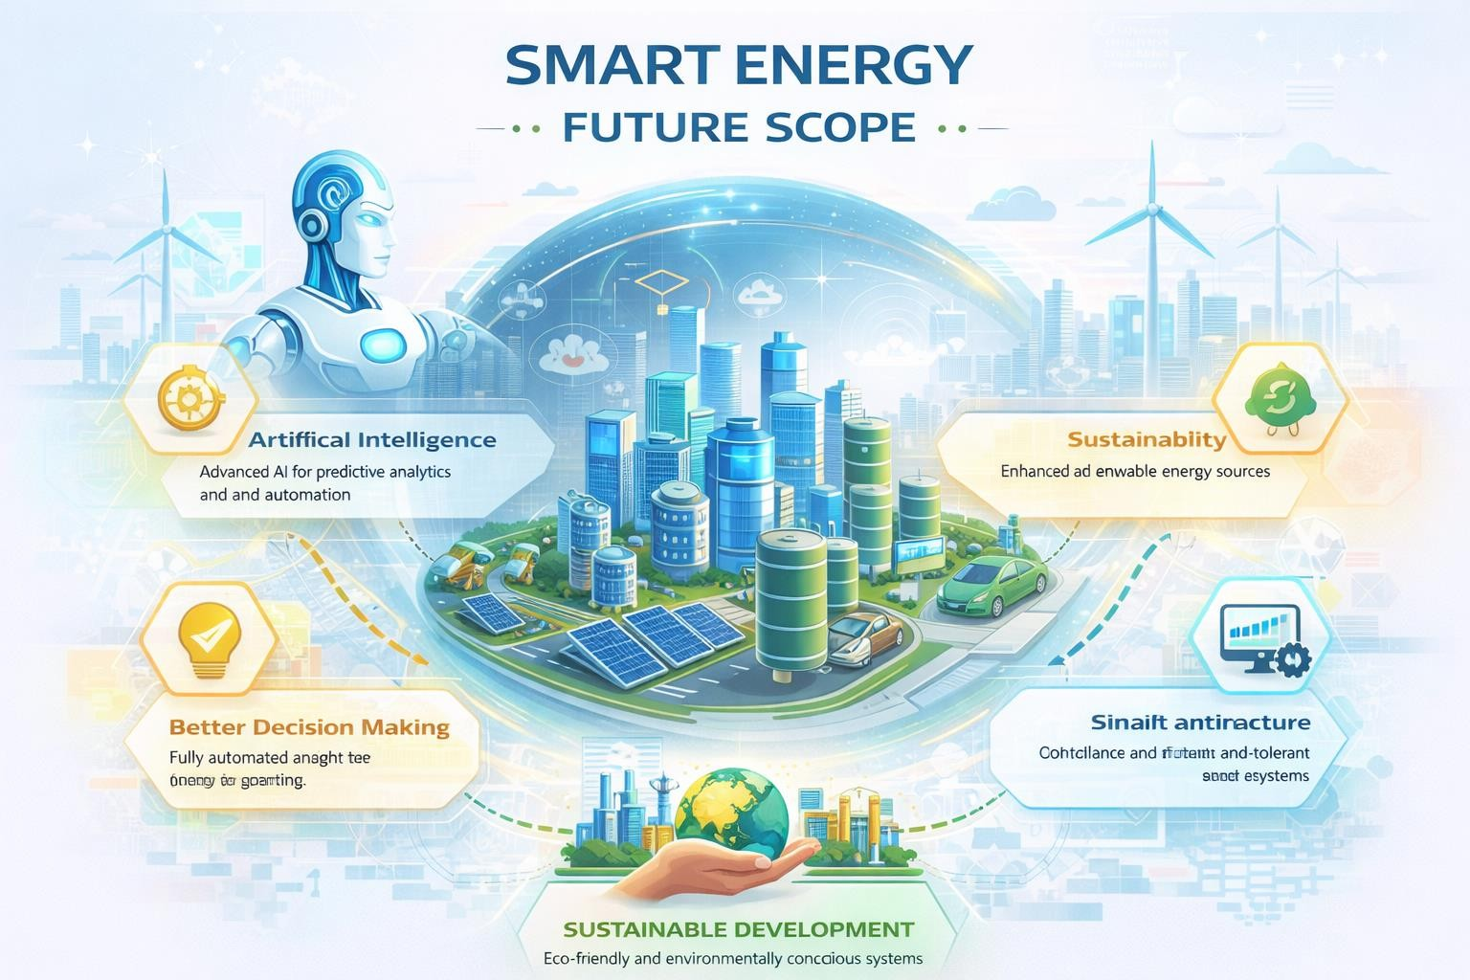

CONCLUSION
Smart Energy Management Systems powered by Big Data Analytics play a crucial role in improving energy efficiency and reliability. By analyzing real-time data from smart meters and IoT devices, these systems help in optimizing energy consumption and reducing wastage. They also support the integration of renewable energy sources, making the energy system more sustainable and environmentally friendly.
In conclusion, the use of advanced technologies such as Big Data, Artificial Intelligence, and cloud computing is transforming traditional energy systems into smart and intelligent networks. As demand for energy continues to grow, Smart Energy Management Systems will become essential for building efficient, cost-effective, and sustainable energy infrastructure in the future.

REFERENCES
- GeeksforGeeks. Big Data Analytics in Power Systems.
https://www.geeksforgeeks.org/big-data-analytics/
- IEEE Xplore. The Evolution of V2G and VPPs in 2026. 3. Mordor Intelligence. Smart Grid Data Analytics Market Report 2026. 4. Mumbai University M.Sc. IT. Soft Computing and Cloud Integration Notes. https://e-next.in/notes/mumbai-university/msc-it/
- OpenText. Top Tech Trends for the Energy Sector 2026.

